

**BOCNY Cash Flow Projections Procedure**

**纽约分行现金流预测操作流程**

Updated: September 2021

更新时间：2021年9月

**Cash Flow Projections Procedure**

**Sep 2021**

|  |  |  |  |
| --- | --- | --- | --- |
| **Version** | **Date Changes Made** | **Author** | **Description of Changes** |
| 1.0 | May 2016 | FMD | Original |
| 2.0 | August 2016 | FMD | MKD Changes to list of data requirements in Section 3 |
| 3.0 | April 2017 | FMD | Update to reflect changes |
| 3.1 | September 2017 | FMD | Update data input frequency to daily |
| 3.2 | October 2017 | FMD | Update to reflect reporting process |
| 3.3 | December 2018 | FMD | Update to reflect minor changes |
| 3.4 | March 2019 | TRY | Update to reflect change of departments |
| 3.5 | August 2019 | TRY | Update to reflect changes |
| 3.6 | July 2020 | TRY | Update to reflect changes |
| 3.7 | July 2021 | TRY | Update to reflect automation process and projection enhancement, align with current business practice |

|  |  |
| --- | --- |
| **Identifying Information** |  |
| **Title** | Cash Flow Projections Procedure |
| **Procedure Owner** | TRY |
| **Contact Information** | Liang Lei, Shunan Liu |
| **Effective Date** | Oct 2021 |
| **Location** | J:\Liquidity and Funding Team\1. Policy & Procedures\1.2 BOC USA Policy & Procedures\ Liquidity Funding Procedures 2021 |
| **Document Type** | Procedure |

|  |  |  |  |
| --- | --- | --- | --- |
| **Approved by** |  | | |
| **Qian (Charlie) Peng**  **SVP & Head of Treasury** |  |  |  | |
| Signature |  | Date: | |

|  |  |  |  |
| --- | --- | --- | --- |
| **Reviewed by** |  | | |
| **Min Zhu**  **EVP** |  |  |  |
| Signature |  | Date |

### Cash Flow Projections Procedure

**1. Overview:**

According to Liquidity Risk Management Policy, Bank of China (“BOC”) U.S. branches are required to produce short-term and long-term cash flow projections. The Cash flow projections would be used as a dynamic liquidity monitoring tool on cash position for management and business units. This procedure introduces the process to produce the cash flow projections.

|  |  |  |  |
| --- | --- | --- | --- |
|  | **Frequency** | **Duration** | **Owner Department** |
| Short-term cash flow projection | Daily | 4 weeks | TRY |
| Long-term cash flow projection | Monthly | 12 months | TRY |

**2. Departments Involved in the Procedure:**

Treasury (TRY)

* Coordinate related stakeholders by leveraging cash flow projection functions in Intraday Liquidity Management System (ILMS) to align with current business practice;
* Populate the short-term and long-term cash flow projection reporting templates;
* Upload TRY’s cash flow projection input data into ILMS;
* Download consolidated cash flow projection data from ILMS;
* Import consolidated cash flow projection data into reporting templates, update HO O/N deposits cash flows based on the communication with HO; Update QNB cash flows when there is material cash flow change;
* Report cash flow projections results to senior management and related departments.

Other business units:

Global Markets Department (MKD)

Corporate Banking Department (CBD)

Financial Institution Department (FID)

Trade Finance Department (TSD)

Bank of China Chicago Branch (CHB)

Bank of China Los Angeles Branch (LAB)

Bank of China Queens Branch (QNB)

* Upload short-term cash flow projection input data into ILMS before 4 pm EST every business day.
* Upload long-term cash flow projection input data into ILMS before the end of 2nd calendar day of each month.
* QNB provide long-term cash flow projection data to TRY when there is material cash flow change.

**3. Short-term and long-term cash flow projection data requirements from relevant business units will include the following:**

MKD

* Brokered CDs
* FDIC Sweep Deposits
* Securities
* Repo/Reverse Repo
* Institutional CDs
* Bond Issuance
* BOC IB & Affiliates Deposits & Funding (overnight and term)
* Funding from 3rd party FI through money market deal
* Loans to 3rd party FI and BOC IB and Affiliates through money market deal

CBD

* New deposits
* Early redemption of deposits
* Large deposit withdrawals
* New term loan funding
* Drawdown of existing facilities
* Change in settlement dates

FID

* Potential new deposits from 3rd party FIs
* Early redemption of term deposits
* Large deposit withdrawals

TSD

* Potential new trade finance loans including discount, factoring and forfeiting
* Prepayment of trade finance loans

CHB

* New deposits
* Early redemption of deposits
* Large deposit withdrawals
* New term loan funding
* Drawdown of existing facilities
* Change in settlement dates

LAB

* New deposits
* Early redemption of deposits
* Large deposit withdrawals
* New term loan funding
* Drawdown of existing facilities
* Change in settlement dates

QNB

* New deposits
* Early redemption of deposits
* Large deposit withdrawals
* New term loan funding
* Drawdown of existing facilities
* Change in settlement dates

TRY would summarize the contractual maturities for related products by using product data from Data Mart, and provide other business units with templates for data input.

**4. Short-term and long-term cash flow projections process flow**

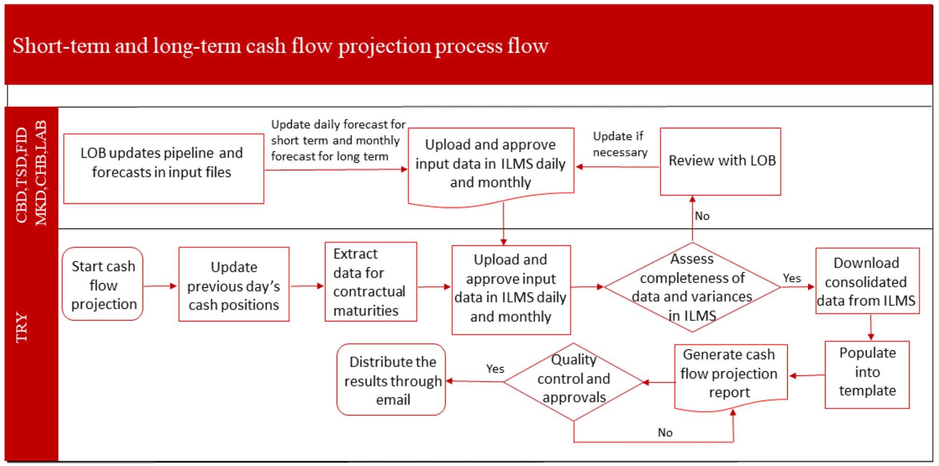

**5. Data input Assumptions**

*Threshold*

The threshold for the relevant business units to input their data is 1 million USD. Due to efficiency of operation, cash flow under 1 million USD would be considered immaterial and not required to report.

It is based on the cash flow impacts as well as the judgements from relevant business lines. Previous projection will be used if no update from business line. TRY may revise the threshold as and when needed, and communicate any proposed changes with the relevant business lines.

*Frequency*

Daily for short-term cash flow projection.

Monthly for long-term cash flow projection.

If the information is not provided timely, TRY will escalate to senior management if it deems necessary.

**6. Contact information**

Below are the primary contact persons and back-up persons for the purpose of cash flow projection from each department.

|  |  |  |
| --- | --- | --- |
| **Department** | **Contact Person** | **Back-up Person** |
| **Corporate Banking Department (CBD)** | **Cao, Qianwen (Elva)** | **Wang, Guanghui** |
| **Global Markets Department (MKD)** | **Huang, Chengyu** | **Leeshue, Marshall** |
| **Trade Service Department (TSD)** | **Xu, Jiayin** | **Wang, Jing**  **Wan, Fanglin** |
| **Financial Institution Department (FID)** | **Zhu, Mo** | **Sun, Wei; Wang, Qinmin** |
| **Treasury (TRY)** | **Lei, Liang** | **Liu, Shunan; Ni, Tianjian;Wong, Brian** |

**7. Reporting Procedure and Hierarchy**

A systematic and hierarchic reporting procedure has been implemented to ensure the accuracy of the report.

For both long-term and short-term cash flow projection, the report follows the review and sign-off process below, before it is distributed to business units, MRD and senior management.

1. The responsibilities of report preparation and review/approval have to be assigned to different persons.
2. It needs to be reviewed and approved by TRY AVP or above.

The reports are not sent to higher review hierarchy or business units unless the previous step is complete by the previous reviewing group and/or person. Each group and/or person is required to sign off as an indication of completion.

The following is the checklist showing the stepwise instruction of running the report. There is also an excel version attached in the appendix.

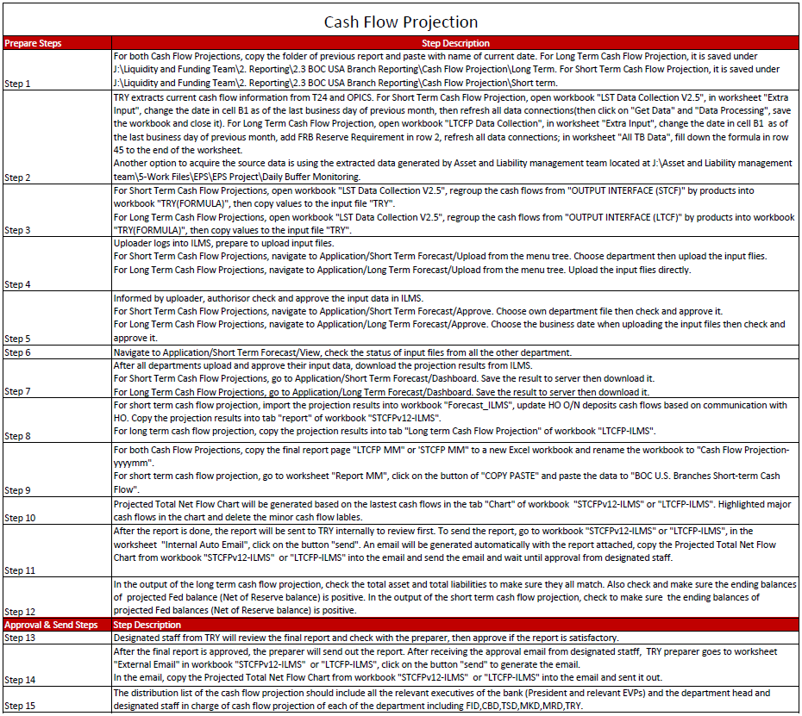

**8. Appendix**

